NPD Procedure Flowcharts
Drishya — mapped onto the IQMS New Product Development Procedures Manual

<Your Name / Emp ID> · 15 September 2026 · Version 1.0
IQMS Enablers · New Product Development Procedures Manual

Table of Contents

1. Purpose
This document shows Drishya — a real-time transport visibility platform for vendors delivering into marketplace fulfilment centres — passing through the procedure set defined in the IQMS New Product Development Procedures Manual. It contains eight flowcharts and, beneath each, a table naming the artefact that carried out every procedure.
Nothing in the evidence tables is written to fill a row. Every entry is a file in the repository, a commit, a test suite with a count, or a fault that was found and fixed. Where a procedure was written for physical product development and has no literal equivalent in software, it is marked as adapted and Section 10 says what carries the same weight instead — it is not quietly skipped.
Table 1: The project these flowcharts describe.
Product | Drishya — real-time transport visibility (RTTV)
Type | Software platform. Hardware is out of scope by a Phase 1 screening decision
Development window | 15 August 2026 to 15 September 2026
Change records | 73 commits on the main branch
Source | 170 Java files, 124 frontend files, 13 database migrations
Verification | 4 independent suites — 82 API assertions, a tenancy write audit, 39 pages in a browser, 26 interaction journeys
Deployment | One CloudFormation stack: EC2, RDS PostgreSQL 16 with PostGIS

2. How to read the flowcharts
Table 2: The drawing conventions used in every figure.
Symbol | Meaning
Rounded pill | Entry or exit condition — what must be true to arrive here, or what is true on leaving
Box with a code tab | One procedure. The tab carries its NPDP number, the body its title
Box with a dashed amber edge | An adapted procedure — see Section 9
Box with a solid teal edge | A spine procedure: not a step passed through once, but a record every later procedure files into
Amber chevron | A gate. The flow cannot continue through it without a decision (Figure 2)
Solid grey arrow | Normal forward flow
Dashed red arrow | Rework — work returning to an earlier procedure because a review or a verification failed
The dashed returns are the part worth reading closely. A chart that only runs top to bottom says nothing the contents page does not; the eight rework loops in this document are all real — each one is a fault that was found at that procedure and sent work back to the one named.

3. The lifecycle
Drishya passed through all five phases and all five gates. This page is landscape because the map is wider than a portrait column can carry legibly.
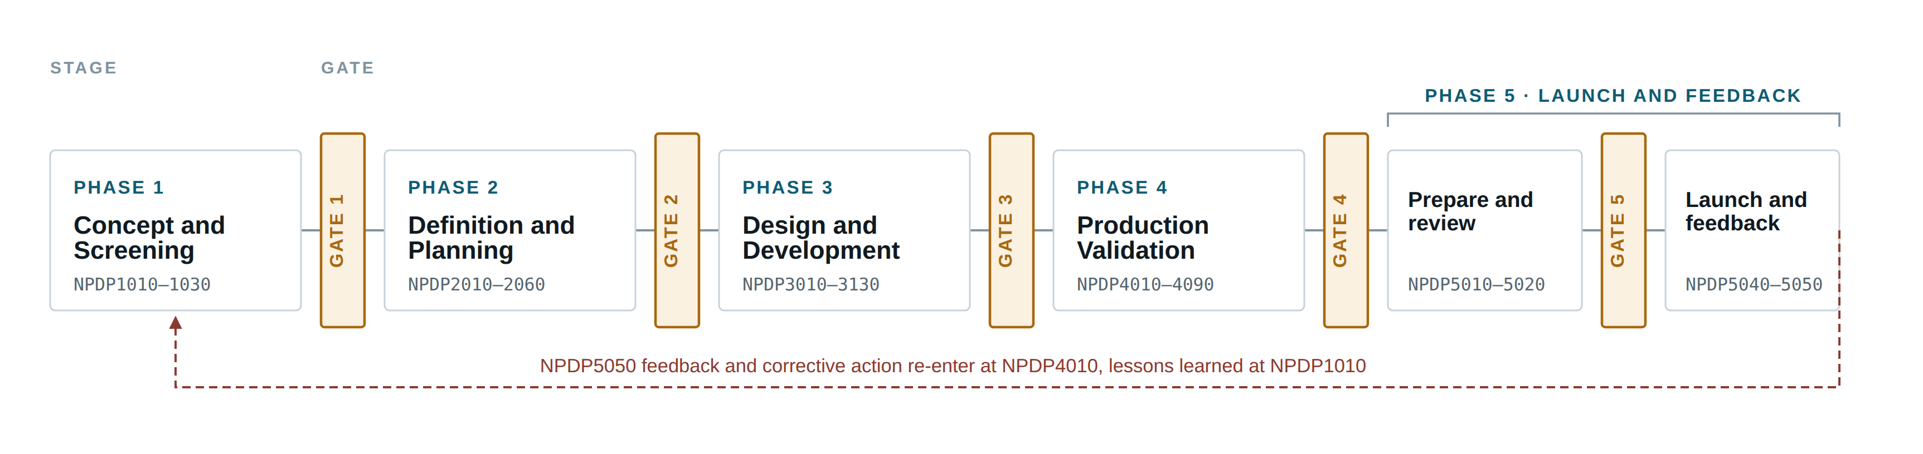
Figure 1: The five phases and five gates, end to end. Gate 5 sits between the two halves of Phase 5, not after it.

4. What happens at a gate
The same decision is taken at all five gates, so it is drawn once. The gate keeper panel appointed under NPDP1020 reviews the phase deliverables against the gate checklist, with the Design History File current, and returns one of five outcomes.
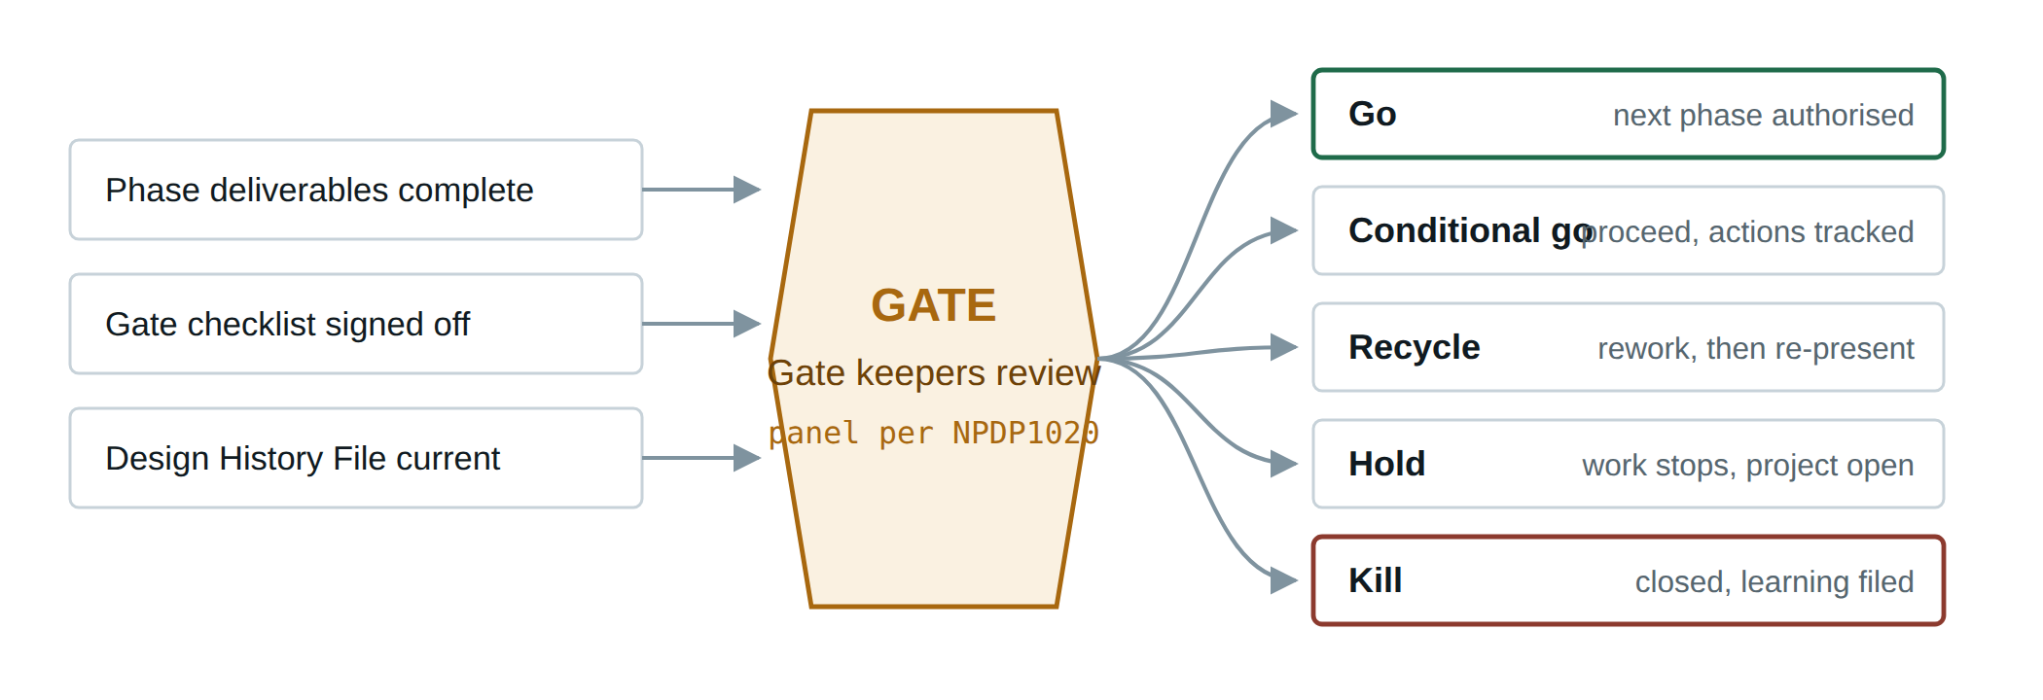
Figure 2: The decision taken at every gate. Drawn once because the pattern is identical at all five.
Check the outcome vocabulary against your own procedure text. Go, conditional go, recycle, hold and kill are the standard stage-gate set; some manuals carry a shorter one or name them differently.

5. Phase 1 — Concept and Screening
NPDP1010 – NPDP1030 3 procedures · terminates at Gate 1
Establish that vendors delivering into a fulfilment centre have a visibility gap worth closing, and fix the boundaries of what would be built.
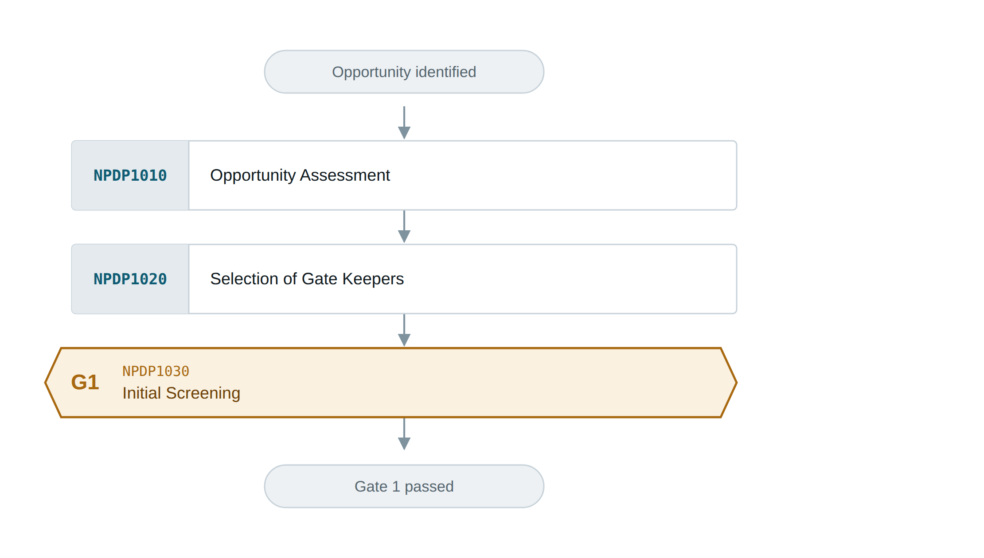
Figure 3: Phase 1 — Concept and Screening (NPDP1010–1030), terminating at Gate 1.

5.1 Procedure evidence
Table 3: Every procedure in Phase 1, and what carried it out in this project.
Procedure | In Drishya | Evidence
NPDP1010  Opportunity Assessment | The blind stretch between two gates | A delay is discovered when the delivery is refused; a paperwork error weeks later on a payment statement, dispute window already closing. Both were knowable earlier.
NPDP1020  Selection of Gate Keepers | ILP review panel | Faculty reviewers appointed as the authority for every gate decision in this project.
NPDP1030  Initial Screening | Scope boundaries fixed | Hardware out of scope, ingest HTTPS only, no paid APIs, no Kafka or Kubernetes, deploy target a t3.micro. Recorded in CLAUDE.md and held to throughout.

6. Phase 2 — Definition and Planning
NPDP2010 – NPDP2060 6 procedures · terminates at Gate 2
Fix the contract the whole system would be held to, and open the record that would carry every decision.
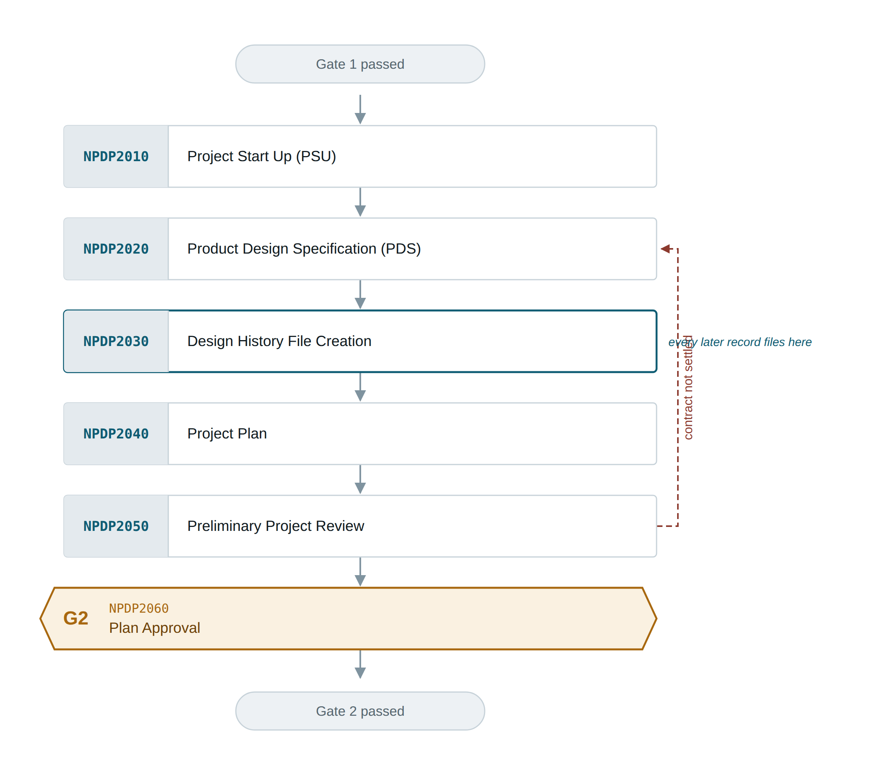
Figure 4: Phase 2 — Definition and Planning (NPDP2010–2060), terminating at Gate 2.

6.1 Procedure evidence
Table 4: Every procedure in Phase 2, and what carried it out in this project.
Procedure | In Drishya | Evidence
NPDP2010  Project Start Up (PSU) | Repository and environment | Two independent projects — Drishya.Backend and Drishya Frontend — plus docker-compose bringing up PostgreSQL 16 with PostGIS in one command.
NPDP2020  Product Design Specification (PDS) | The wire contract | Every enum carries an explicit @JsonValue string matching the frontend vocabulary exactly. Timestamps cross as epoch milliseconds, never ISO. promisedAt and predictedAt are both kept and neither may overwrite the other.
NPDP2030  Design History File Creation | The repository and CLAUDE.md | Git history is the design record; CLAUDE.md is the reasoning behind it. Every trap this project hit is written down there at the moment it was understood.
NPDP2040  Project Plan | Four verification layers, planned up front | API, tenancy, page render and interaction journeys — chosen because each layer can pass while the one above it is broken.
NPDP2050  Preliminary Project Review | Architecture walkthrough | Layering, tenancy boundary and the prediction seam reviewed before implementation started.
NPDP2060  Plan Approval | Gate 2 | Plan and specification accepted; build authorised.

7. Phase 3 — Design and Development
NPDP3010 – NPDP3130 13 procedures · terminates at Gate 3
Build the platform and prove it works — including proving it does not leak one customer’s data to another.
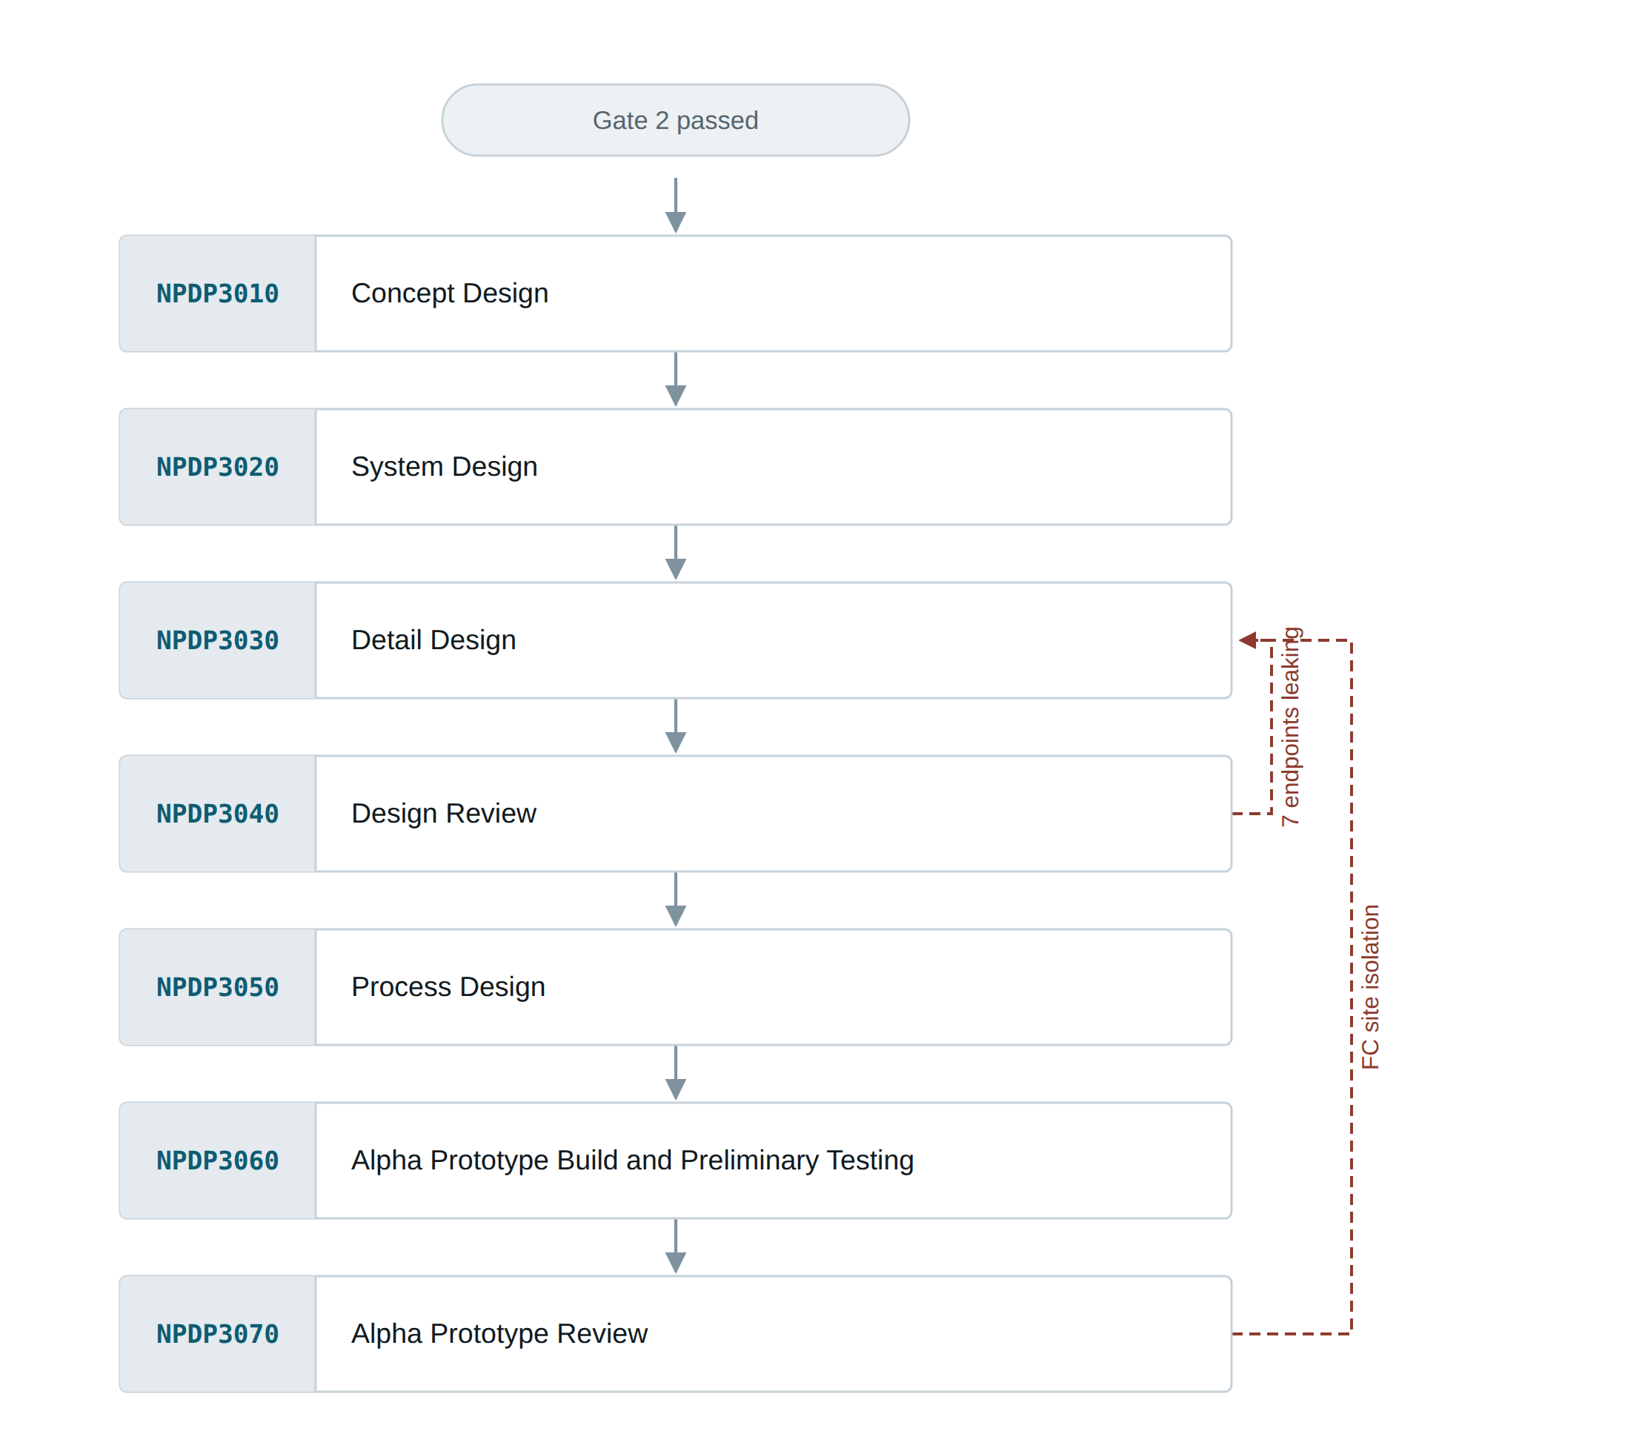
Figure 5a: Phase 3 — Design and Development, first part (NPDP3010–3070).
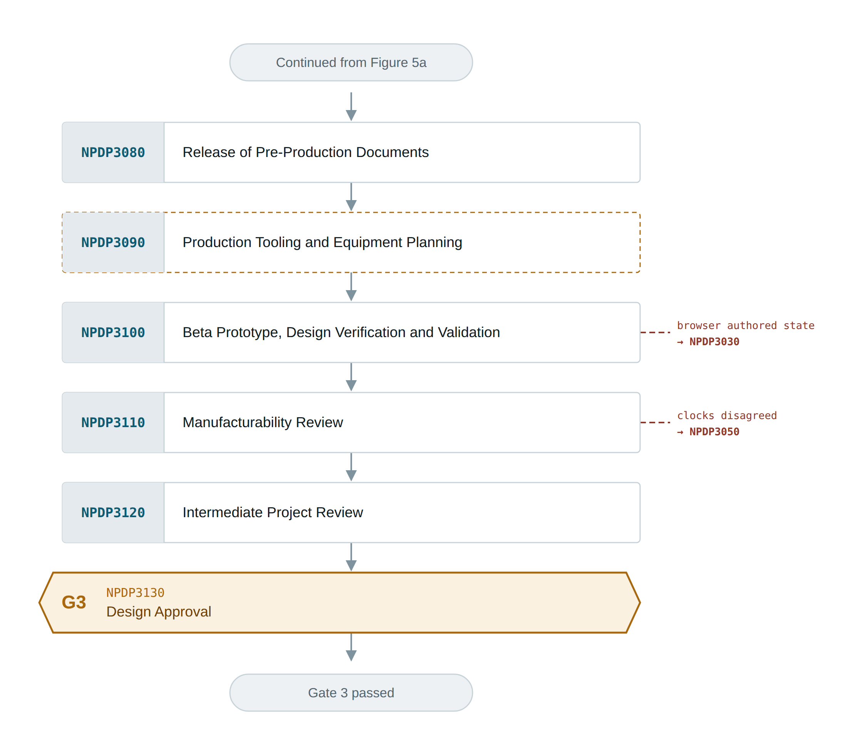
Figure 5b: Phase 3 — Design and Development, second part (NPDP3080–3130), terminating at Gate 3.

7.1 Procedure evidence
Table 5: Every procedure in Phase 3, and what carried it out in this project.
Procedure | In Drishya | Evidence
NPDP3010  Concept Design | One shipment, three portals | A single shipment object with three bounded views: the vendor who books it, the driver who carries it, the fulfilment centre that receives it.
NPDP3020  System Design | Layering and the choke points | domain / repo / dto / service / web, with tenant filtering in the repository layer. On the browser side every call goes through services/client.js; nothing calls fetch directly.
NPDP3030  Detail Design | The implementation | 170 Java source files, 124 frontend source files, 13 Flyway migrations, schema managed with ddl-auto off.
NPDP3040  Design Review | Tenancy review | Commit 7256c8b records the findings: every inherited listing endpoint was returning all tenants’ rows to any authenticated caller.
NPDP3050  Process Design | The verification estate | Testcontainers against real PostGIS because H2 cannot answer ST_DWithin; Playwright for the two browser layers; a tenancy audit script that probes every write path.
NPDP3060  Alpha Prototype Build and Preliminary Testing | v0.1, 15 August | Commit 45cae0a — "v0.1 working full-stack Drishya". First build where a consignment could be booked, driven and received end to end.
NPDP3070  Alpha Prototype Review | Isolation found to be one-sided | The receiving desk is deliberately cross-tenant, and that hid the fact it is still bounded to one site. Bhiwandi could read Manesar’s board and gate its vehicles out.
NPDP3080  Release of Pre-Production Documents | README, CLAUDE.md, DEPLOYMENT.md, OpenAPI | Swagger UI at /swagger-ui.html and the document at /v3/api-docs, both public; the endpoints they describe are not.
NPDP3090  Production Tooling and Equipment Planning | Build and deployment toolchain | No physical tooling exists. Standing in its place: the two Dockerfiles, docker-compose, the CloudFormation template, and the Testcontainers and Playwright estates that any build must pass.
NPDP3100  Beta Prototype, Design Verification and Validation | Four suites, 147 checks | 82 API assertions signed in as two vendors; every write path probed as the wrong tenant, every line must read blocked; 39 pages in a real browser as every role; 26 interaction journeys.
NPDP3110  Manufacturability Review | Will it run on the target box | Hikari pool capped at 5 and the JVM footprint kept modest, because the deploy target is a t3.micro with a db.t4g.micro behind it.
NPDP3120  Intermediate Project Review | Pre-deployment review | Verification estate green, isolation proven with two tenants, documentation released.
NPDP3130  Design Approval | Gate 3 | Design accepted; deployment authorised.

8. Phase 4 — Production Validation
NPDP4010 – NPDP4090 9 procedures · terminates at Gate 4
Prove the thing runs on real infrastructure, under real constraints, before anyone is asked to look at it.
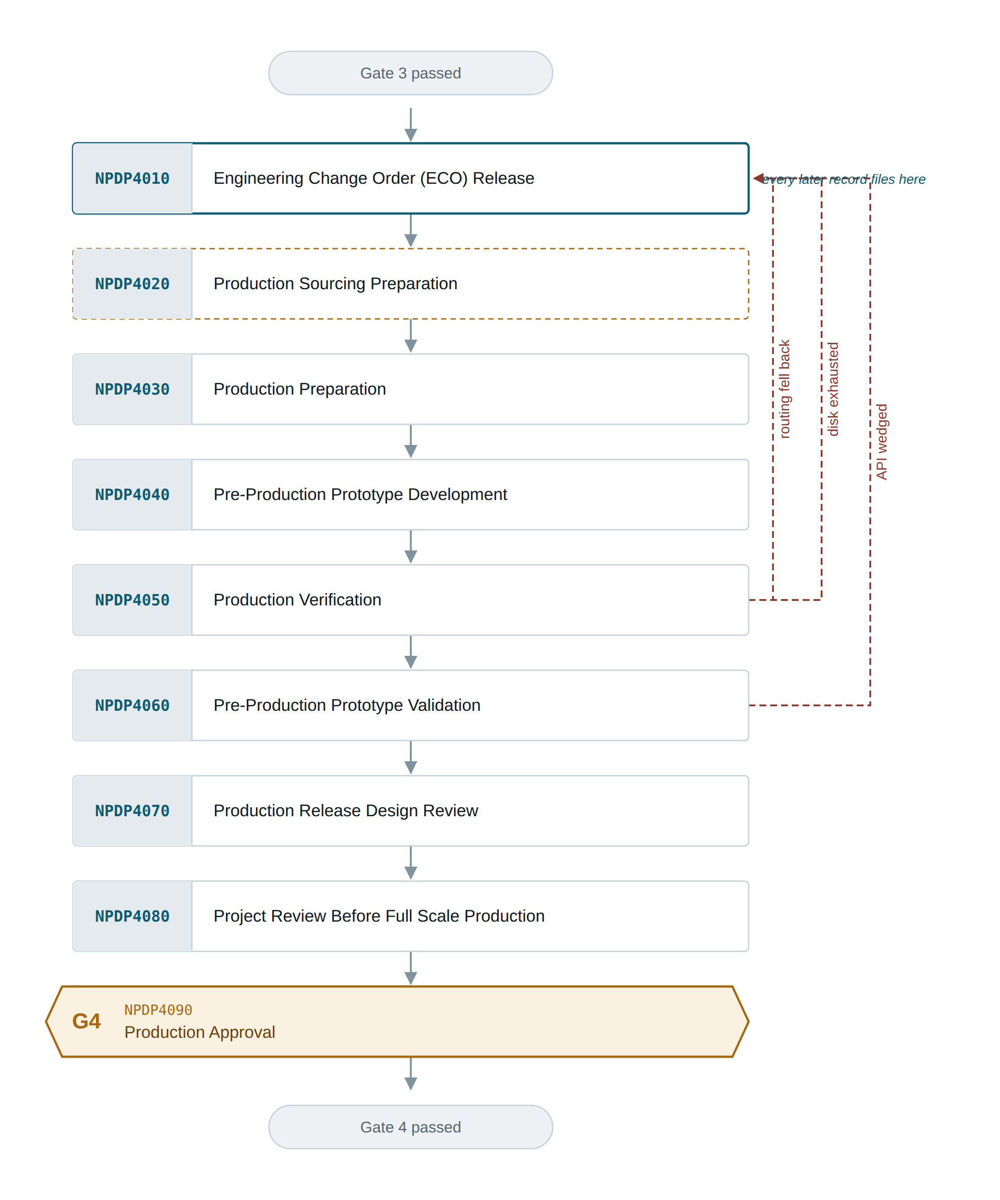
Figure 6: Phase 4 — Production Validation (NPDP4010–4090), terminating at Gate 4.

8.1 Procedure evidence
Table 6: Every procedure in Phase 4, and what carried it out in this project.
Procedure | In Drishya | Evidence
NPDP4010  Engineering Change Order (ECO) Release | Every fix, as a commit | 73 commits on main between 15 August and 14 September. Each carries what was wrong, why it was not visible, and how it was proven fixed.
NPDP4020  Production Sourcing Preparation | Cloud resource selection | No supplier sourcing. Instead: region ap-south-1, EC2 plus RDS sized deliberately, and three things ruled out for billing hourly — load balancer, NAT gateway, multi-AZ.
NPDP4030  Production Preparation | One CloudFormation stack | aws/drishya.cfn.yaml brings up the whole environment and one delete-stack removes it. Secrets reach the instance through user data, never the repository.
NPDP4040  Pre-Production Prototype Development | The deployed instance | Images built on the instance rather than pushed, because the upload link could not sustain a push to ECR.
NPDP4050  Production Verification | What only the real environment showed | Three faults invisible locally: the router mislabelling its reply encoding so every booking drew a straight line; the root volume filling until a deploy died inside a build layer; the API wedging with only a reboot to recover it.
NPDP4060  Pre-Production Prototype Validation | The three-role journey, deployed | Vendor books, driver starts and carries, receiving desk books the dock and raises the goods receipt — on the deployed site, as three separate signed-in accounts.
NPDP4070  Production Release Design Review | Codebase audit | A full pass over tenancy, authorisation and the write paths, with the residual gaps written down rather than quietly closed.
NPDP4080  Project Review Before Full Scale Production | Readiness review | Memory limit, watchdog and disk reclamation in place so the environment recovers without a human.
NPDP4090  Production Approval | Gate 4 | Environment accepted for demonstration.

9. Phase 5 — Launch and Feedback
NPDP5010 – NPDP5050 5 procedures · terminates at Gate 5
Put the product and its documentation in front of the panel, and route what comes back into the change process.
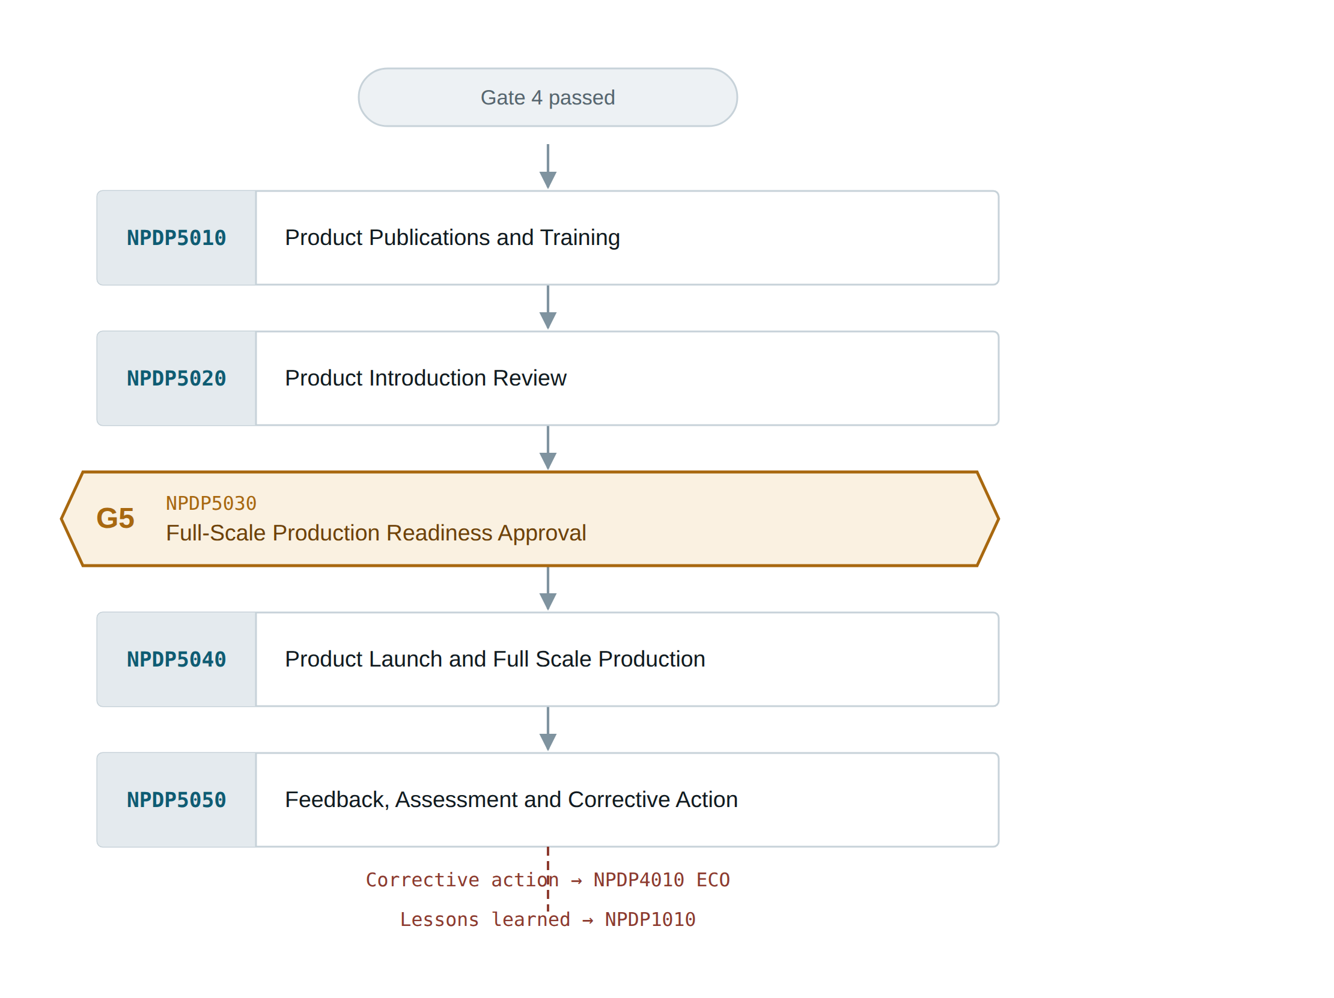
Figure 7: Phase 5 — Launch and Feedback (NPDP5010–5050), with Gate 5 at NPDP5030.

9.1 Procedure evidence
Table 7: Every procedure in Phase 5, and what carried it out in this project.
Procedure | In Drishya | Evidence
NPDP5010  Product Publications and Training | Final MVP Report and demo accounts | The report covers purpose, components, source, outputs, issues and setup. Three one-click demo accounts so a reviewer never types a password.
NPDP5020  Product Introduction Review | Walkthrough rehearsal | Every screen checked as every role against a freshly seeded database.
NPDP5030  Full-Scale Production Readiness Approval | Gate 5 | Readiness confirmed before the demonstration, not after.
NPDP5040  Product Launch and Full Scale Production | The ILP demonstration | The deployed site, driven live through the three portals.
NPDP5050  Feedback, Assessment and Corrective Action | Findings routed back as ECOs | A consignment booked through the form never reached the receiving desk’s board. Root cause: the promised slot was a flat 36 hours from booking. Now costed from the pickup time against the same lane history the engine uses.

10. Adapted procedures
Two procedures in the manual are written for the development of a physical product. Neither was skipped. Both were carried out in the form the product actually takes, and both are marked in the flowcharts with a dashed amber edge.
Table 8: Procedures adapted for a software product, and what carried them.
Procedure | Why it does not apply literally | What was done instead
NPDP3090  Production Tooling and Equipment Planning | There is no physical tooling to plan, no jigs, fixtures or moulds, and no equipment to install on a line. | The build and deployment toolchain was planned and built to the same purpose: two Dockerfiles, docker-compose for the local environment, the CloudFormation template for the deployed one, and the Testcontainers and Playwright estates any build must pass before release.
NPDP4020  Production Sourcing Preparation | There is no bill of materials to source and no supplier to qualify. | Cloud resources were selected and sized with the same discipline: region ap-south-1, EC2 and RDS sized to the workload, and a load balancer, NAT gateway and multi-AZ database each ruled out on record because they bill hourly and none was needed.

11. Rework loops
Eight faults sent work back to an earlier procedure. They are collected here because, taken together, they are the strongest evidence that the gates did their job — each was caught at a review or a verification rather than by a user.
Table 9: Every rework loop in the flowcharts, and what caused it.
Found at | Returned to | What was wrong
NPDP2050 | NPDP2020 | The wire contract was not settled: enum values and timestamp format had to be fixed before the plan could be approved
NPDP3040 | NPDP3030 | Every inherited listing endpoint returned all tenants’ rows to any authenticated caller
NPDP3070 | NPDP3030 | The receiving desk is cross-tenant by design, which hid that it is still bounded to one site
NPDP3100 | NPDP3030 | The browser was authoring vehicle positions, so three signed-in users saw three different answers
NPDP3110 | NPDP3050 | The simulator and the prediction engine kept different clocks, so the vehicle arrived before the estimate moved
NPDP4050 | NPDP4010 | The routing service mislabelled its reply encoding, so every booking silently drew a straight line
NPDP4050 | NPDP4010 | The instance root volume filled, and a deploy died inside a build layer reporting a disk error as a build failure
NPDP4060 | NPDP4010 | The API wedged under memory pressure with no limit and no watchdog, recoverable only by reboot
The closing loop in Figure 1 is the ninth and it is still running: NPDP5050 routes field feedback back to NPDP4010 as an engineering change. The most recent example is a consignment booked through the form that never appeared on the receiving desk’s board, because the promised slot was a flat 36 hours from booking rather than costed from the pickup time.

12. List of figures
- Figure 1: The five phases and five gates, end to end. Gate 5 sits between the two halves of Phase 5, not after it.
- Figure 2: The decision taken at every gate. Drawn once because the pattern is identical at all five.
- Figure 3: Phase 1 — Concept and Screening (NPDP1010–1030), terminating at Gate 1.
- Figure 4: Phase 2 — Definition and Planning (NPDP2010–2060), terminating at Gate 2.
- Figure 5a: Phase 3 — Design and Development, first part (NPDP3010–3070).
- Figure 5b: Phase 3 — Design and Development, second part (NPDP3080–3130), terminating at Gate 3.
- Figure 6: Phase 4 — Production Validation (NPDP4010–4090), terminating at Gate 4.
- Figure 7: Phase 5 — Launch and Feedback (NPDP5010–5050), with Gate 5 at NPDP5030.

